SSDs in the data center: The TCO (Total Cost of Ownership) advantage!
Cost per gigabyte is not the whole story, so understanding TCO over the life of your Data Center investment is crucial to your bottom line. While cost per gigabyte can a be useful metric, it is not accurate when used alone because SSD (Solid State Drives) offer numerous advantages over HDD (Hard Disk Drives) that are not measured by cost per gigabyte. It is the Opex portion of storage costs that see the greatest benefit from SSD over HDD use. Typical TCO consists of the following:
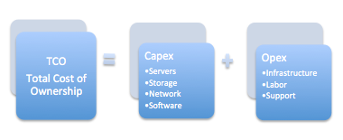
Capex - While SSD’s command a slightly higher cost per gigabyte, they offer much higher density (Samsung 3D -VNAND is at 32 TB SSDs) and performance (1000X IOPs) and can reduce Capex because the cost of the other equipment is lower. Density and performance per rack is needed to calculate Capex accurately.
Opex - Is more difficult to evaluate due to the costs often being hidden. Electricity, reliability and floor space need to be thoroughly evaluated.
Electricity - SSDs have a tremendous advantage in power efficiency compared to HDDs. SSDs often consume less than half the power while delivering 100’s of times higher IOPs (input/output operations per second). This results in orders of magnitude IOPs per watt, SSDs can equalize the difference in HDD costs in a few months due to their power performance superiority.
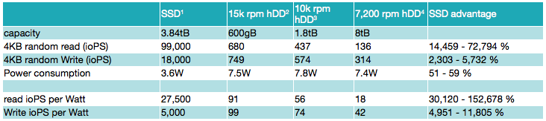
Reliability - The Schroeder-Gibson study shows HDDs have an AFR (Annual Failure Rate) of 3% on average. A typical five year life span for HDDs usually includes a 15% replacement rate. SSDs have an AFR of about 0.5%. Even with manufacturers’ warranties, the direct costs of HDD failure include downtime, labor, data loss risk and customer impact. SSDs do not need the extensive redundancy of HDD systems (RAID 5 or 6). Contrasting the mechanical aspects of HDDs, SSD lifespan is easily and accurately estimated. SSDs have non-moving NAND chips which have been validated to withstand specific program/erase (P/E) cycles. In addition, SSD lifespan can be tailored to fit your IO workload and targeted lifespan by configuring the SSDs’ over-provisioning level.
Floor Space - Outgrowing a data center is a very difficult and expensive problem. SSDs focus on capacity expansion and performance enhancements per rack. At the high-end, 64 layer 3D-VNAND technology (GEN 4) from Samsung in 2.5” SSD with up to 32TB can significantly reduce floor space or allow for significant density and performance improvements.
Enterprise SSD vs Client SSDs - They are very different!
First, client SSDs are not designed or validated for enterprise use, and are not warranty supported if used in an enterprise application. Enterprise SSDs have their NAND chips validated to withstand the much greater enterprise P/E cycles demanded. Enterprise-grade data protection against power loss is only found in enterprise (not client) SSDs with built-in backup power circuitry. Enterprise SSDs also have a much higher level of over provisioning for enterprise level IOPs and lifespan requirements.
Conclusion: Cost per gigabyte is a useful metric. TCO includes several other metrics such as IOPs per watt and capacity and performance per rack. TCO is a mix of several metrics; each having its own weight in your unique enterprise environment. Samsung is clearly the leader in enterprise SSDs with over half the worlds market share. The reason is Samsungs commitment to leading the world with their 3D-VNAND Flash technology and driving enterprise SSD technology with support for SATA, SAS and NVMe (U.2 & HHHL) capabilities. Samsung’s priority is with their strategic relationships with Enterprise level datacenter partners, we at Customer 1st can make you a Samsung partner!

