Software Defined Storage Solution - ScaleIO and Samsung SSD

  - 3/16/17 10:21 AM
  - Samsung Semiconductor, Inc.

Table of Contents
Software Defined Storage Solution - ScaleIO and Samsung SSD 1
1 Software Defined Storage - Solution Overview 2
2 ScaleIO Hyper-converged approach 3
3 APPENDIX - HA Feature Coverage 6

Software Defined Storage - Solution Overview
Support IT best practices for Storage – Consolidate and Standardize
ScaleIO software defined storage:
- ScaleIO MDM - ScaleIO MetaData Manger – like a master node
SDS - ScaleIO Data Server – like a storage target
SDC – ScaleIO DataClient – like an application server
- Scale IO can be configured with dedicated application servers (SDC) and dedicated storage servers (SDS). Or ScaleIO can be configured as hyper-converged where every server is both application and storage.
- Scale IO employs a special protocol, so Scale IO software is installed on both SDS and SDC (both clients and servers).
Scope of work –
- The analysis is a non-Tiered configuration where both SDS and SDC software runs on every server (hence the high DRAM).
- Beyond the scope of this paper – this paper is NOT involving VMware and/or Docker. These services can be added on top of the hardware foundation provided by this paper.

ScaleIO Hyper-converged approach
 | Hyper-Converged Per-NODE View
 | H1 - (baseline) published by Dell | H2 - Samsung SSD  SSD performance  and SSD bulk | H3 - Samsung SSD  performance optimized
ScaleIO SDS+SDC | Server (Dell R730xd or equivalent)  2 socket, total 20 Core CPU | Server (Dell R730xd or equivalent)  2 socket, total 20 Core CPU | Server (Dell R730xd or equivalent)  2 socket, total 20 Core CPU
Server CPU | E5-2600 Intel 10 Core | Intel 20 Core | Intel 20 Core
RAM | 512GB DDR4 - Samsung | 512GB DDR4 - Samsung | 768GB DDR4 - Samsung
Storage Controller | Raid controller (PERC H730 or similar) | Raid controller (PERC H730 or similar) | none
Storage | 24x 1.2TB 10K RPM HDD | - 2x 1.9 TB NVMe SSD  Samsung SM963  - 18x 15.4TB SAS SSD  Samsung 1633a | - 4x 6.4 TB NVMe SSD  Samsung PM1725a
OS version | Linux 4.4.0-040400-generic | Linux 4.4.0-040400-generic | Linux 4.4.0-040400-generic
ScaleIO Software | - Both SDC and SDS – ScaleIO Data Client and ScaleIO Data Server | - Both SDC and SDS – ScaleIO Data Client and ScaleIO Data Server | - Both SDC and SDS – ScaleIO Data Client and ScaleIO Data Server
Network | 4x 10Gbe | 2x 40Gbe | 4x 40Gbe
Storage | TOR switch S4048-ON  48x 10Gbe, 6x 40Gbe ports | TOR switch S6010-ON  32x 40Gbe ports | TOR switch S6100-ON  64x 40Gbe ports

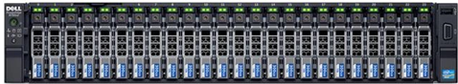
Server – 2U Rack Mount, 24 Slots for SAS, 4 slots for NVMe (Dell R730xd or equivalent)

RACK LEVEL– Hyper-Converged View
Rack Level | Baseline | Samsung SSD  SSD performance/SSD bulk | Samsung SSD  performance optimized
Network Top of Rack | 2x S4048  - 48x 10Gb ports ea  - 6x 40Gb ports ea  MDM – 3x 4x 10Gb ports  SDS+SDC – 12x 4x 10Gb ports  TOR Out – 12x 40Gb ports  Out of Band – 15x 1Gb port | 2x S6010-ON  - 32x 40Gb ports ea  MDM – 3x 4x 10Gb ports  SDS+SDC – 12x 2x 40Gb ports  TOR Out – 12x 40Gb ports  Out of Band – 15x 1Gb port | 2x S6100-ON  - 64x 40Gb ports ea  MDM – 3x 4x 10Gb ports  SDS+SDC – 12x 4x 40Gb ports  TOR Out – 12x 40Gb ports  Out of Band – 15x 1Gb port
MDM - Scale IO Manager Node | 3 server nodes (Dell R630 or equivalent)  128GB RAM  1x 400GB SSD, 3x 1.2TB HDD  PERC H730 controller  4x 10GBe | 3 server nodes (Dell R630 or equivalent)  128GB RAM  2x 1.9 TB SSD, no PERC  4x 10GBe | 3 server nodes (Dell R630 or equivalent)  128GB RAM  2x 1.9 TB SSD, no PERC  4x 10GBe
SDS+SDC Servers | 12 nodes (Dell R730xd or equivalent) | 12 nodes (Dell R730xd or equivalent) | 12 Nodes (Dell R730xd or equivalent)
Usable Storage | 129TB | 1.7PB | 130TB
Estimated price | $171K | $4.2M | $569K
Est. Performance | 72,000 IOPs | 45M | 46M
Est. Power | 7.2 KWatts per year  $10,844 per year | 5.6 KWatts per year  $8,414 per year | 4.3 KWatts per year  $6,564 per year

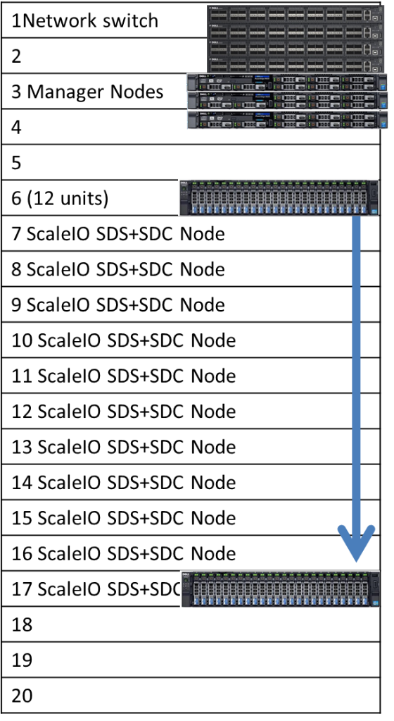
Key Ratios Bigger is better
 | Baseline with 1.2TB 10K rpm HDD/node | SSD performance /SSD bulk  15.4TB SAS SSD+ 2x NVMe | Samsung SSD performance  4x 6.4TB NVMe
Perf/$ | 0.42 | 11 | 84
Capacity/$ | 755 | 411 | 229
Perf/Watt | 10 | 8190 | 1150
Capacity/Watt | 18 | 314 | 30
Key Ratio summary
- HDD wins on GB/$, but loses badly on Performance value and Power consumed
- SSD 16TB design is the all-around winner, a good balance between performance-capacity-price-power
- SSD 6.4TB NVMe is the performance winner
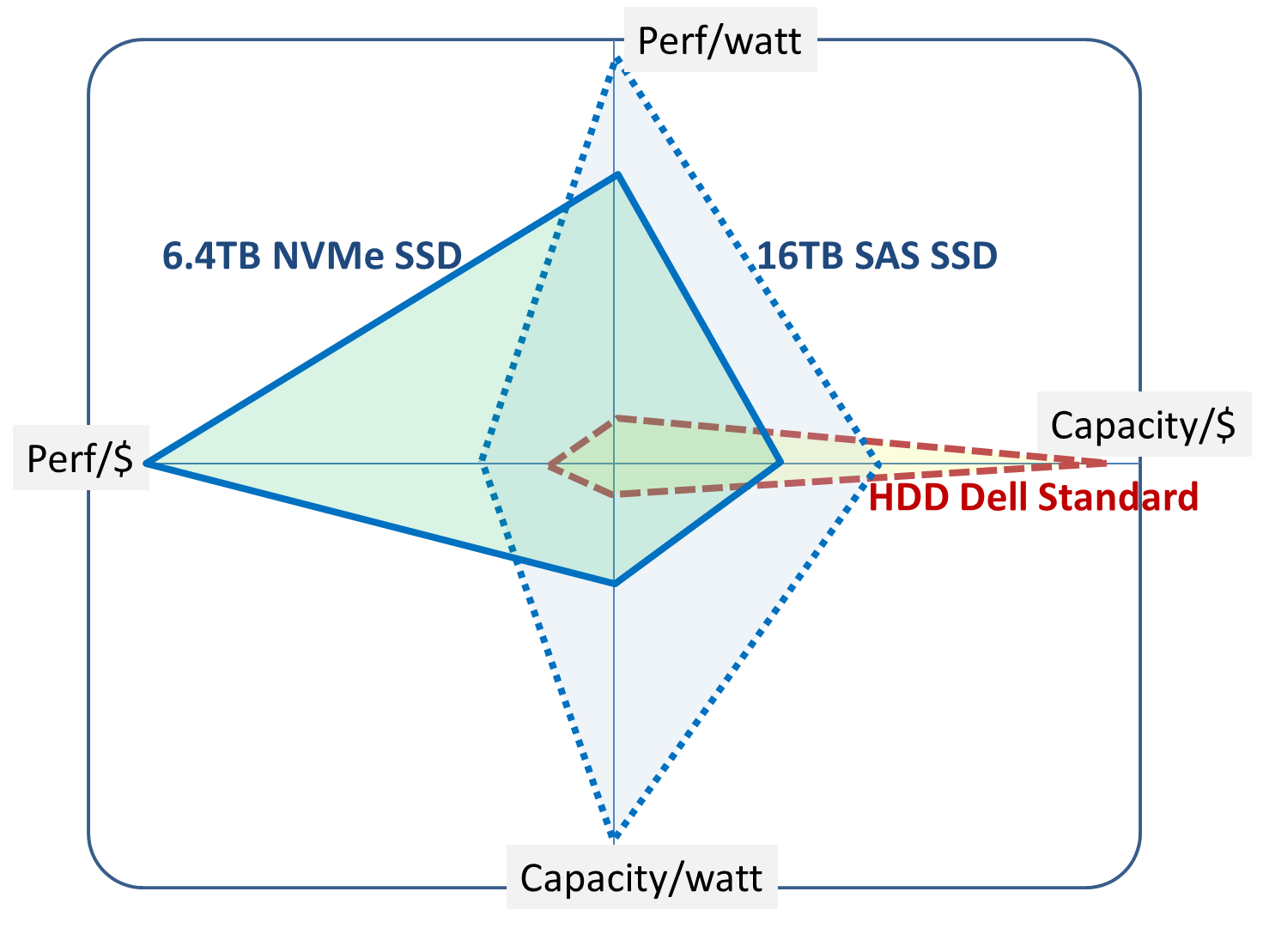

APPENDIX - HA Feature Coverage
RAID Functionality  at SSD speed | RAID does not slow down SSD in ScaleIO  the penalty, is 2x replication  ScaleIO Provides recovery if device fails  ScaleIO provides recovery if node fails
Snapshot and replication | Yes, supported
Compression | ??

Performance bench - https://www.youtube.com/watch?v=M5h2X5bq8fQ
Slideshare - http://www.slideshare.net/walshe1/emc-scaleio-overview

