Understanding the needs of our Enterprise and Data Center Customers:

The “Enterprise Customer Continuum” contains 'pure-play Data Centers' on one end and 'OEM Enterprise Builders' on the other end of the spectrum. In the middle we find the ‘Custom White-box’ builders. This is a continuum where no two customers are at the same position with their business model and needs. Below we have segmented the Enterprise Continuum as such:

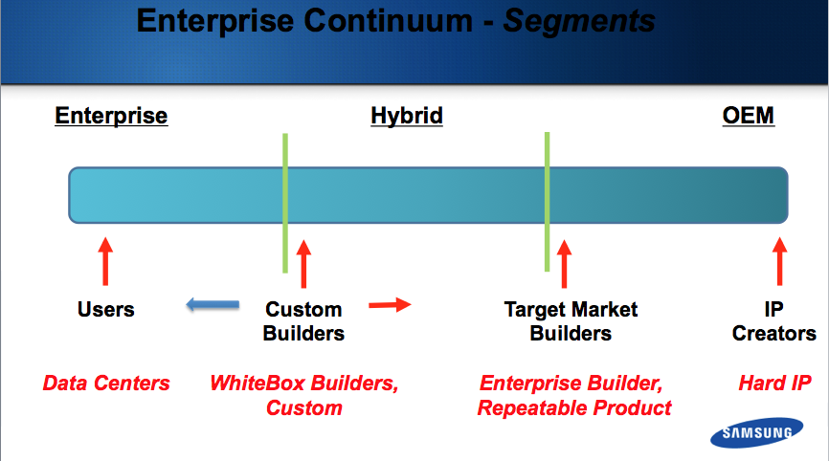

In general terms, we have three Enterprise market segments (Users, Custom Builders, Target Market Builders) outside of the fourth OEM segment. All segments have growing needs for SSD and Memory, but differ in the design and procurement needs that surround these components. They also differ in the performance and sophistication needs of these components. (SATA vs. NVMe technologies or Consumer vs. Enterprise operation specs for example.) These 'system requirement’ differences translate directly to Enterprise Customers’ weighted importance for Reliability, Price, Vendor Relationship, Vendor Branding, Engineering Support and Device Customization. The combination of these priorities then drive the buying decision, support model and information gathering processes for our customers. Below are some of the different needs by priority in each segment:

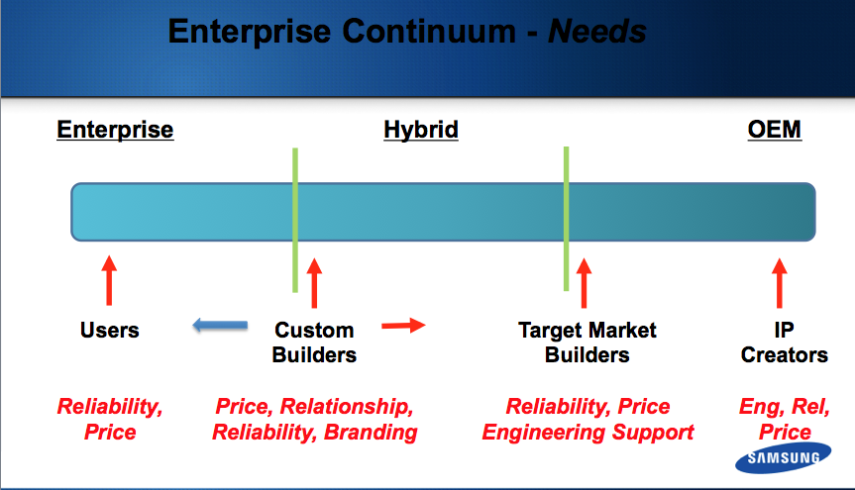The goal of Customer 1st, along with our Principals such as Samsung Semiconductor and Viking Technology, is to satisfy the right mix of our Enterprise Customers’ needs, their unique mix of their needs. The way Samsung and Viking satisfy customers unique needs is through Customer 1st. They rely on our Sales Engineers to work directly with the unique customer groups and pull in the resources needed including; Executive teams as well as Marketing, Engineering and Operations experts. Let’s look at our Enterprise customers’ most likely needs by segment starting at the pure Data Center:

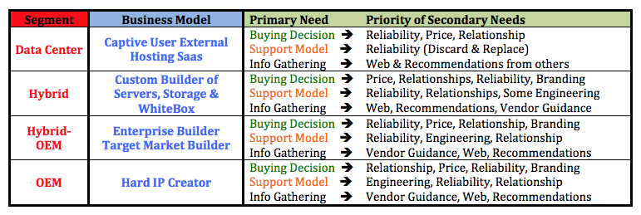

Our customers across the Enterprise continuum have varied Business Models and varied needs with regards to their buying, support and information gathering processes. Customer 1st recognizes these differences and engages with the right formula for success based on each of our customers' specific needs. For Customer 1st, it’s all about understanding what our Customers’ customers’ customers want and need, then delivering to our customers what they want and need to be successful!

